ICMIEE24-XXX[paper number; will be assigned by Conference Secretariat]
Title of the paper [Times New Roman, Size 14, Bold]
(A 10pt line space)
Tanvir A. Choudhury^{1,*}, Md. Shariful I. Khan² [Times New Roman, size12, Italic]
¹ Department of Mechanical Engineering, Khulna University of Engineering & Technology, Khulna-9203, BANGLADESH
² Department of Mechanical Engineering, University of Texas, El Paso, TX 79968, USA [Times New Roman, size10]
(Two lines space with 10pt)

ABSTRACT
The abstract should clearly be stated the objectives, methodology, results and conclusion between 250-300 words.
(A 10pt line space)
Keywords: Please write three to five keywords in the center.
(Two lines space with 10pt)

1. Introduction (Top heading should be in bold)
You are welcome to the ICMIEE 2024 which is going to be held on 02-04 January, 2025 at KUET. Papers should be prepared according the following instructions given through the template. This MS-Word document can also be used as a template. When the paper is ready, make a pdf file with 600 dpi resolution and save the file as paper-number.pdf (For example ICMIEE24-XXX.pdf). Then be sure to verify that you can correctly view your pdf file with an English version of the pdf viewer. The size of the pdf file should be less than 2.0 MB.
(A 10pt line space)
2. Length of the paper and paper settings
The overall length of the paper, including figures and tables, must be limited to 6 pages only. Authors are requested to prepare the article with the paper size A4, i.e. 210 mm by 297 mm. The top and bottom margins are of 25 mm, and the left and right margins are of 20 mm. The main text should be written in two-column format with a font of 10pt Times New Roman. The interval of columns should be 10 mm. Your full paper submission should in two columns.

3. Format
Manuscripts should consist of the title, author(s), author’s affiliation and address, abstract, keywords, and main text. Title, author(s), author’s affiliation and address, abstract and keywords should be written according to the format given above.

3.1 Main text
Main text should begin at two lines below keywords.

3.2 Heading
Examples of heading are as follows.

3.3 Equations
Equations and symbols should be written with 10pt italic font except super/sub scripts. There should be one line space upper and lower equation. In the main text, an equation is explained as Eq. (1).
(A 10pt line space)
$\frac{∂u}{∂x}+\frac{∂v}{∂y}=0$ (1)
(A 10pt line space)
3.4 Figures, tables, pictures
Keep margins. Figures and tables should be explained in main text as Fig.1, Table 1.
(A 10pt line space)
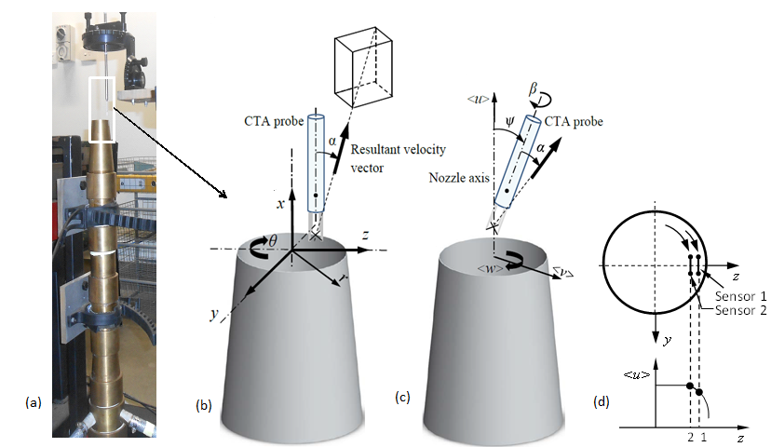
(A 10pt line space)
Fig.1 Experimental setup.
(A 10pt line space)
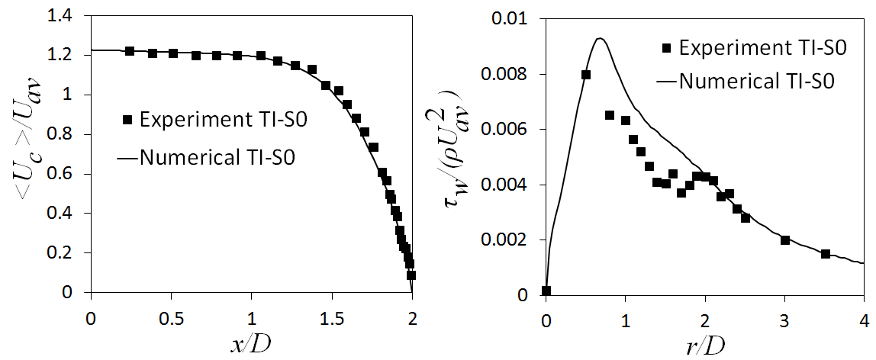
(A 10pt line space)
Fig.2 Centerline velocity and wall shear stress profiles for the case TI-S0.
(A 10pt line space)
Table 1 Historical data of vapor pressure of ammonia.
Author | Year | T | p | Ref.
Keyes | 1918 | 240-398 | 0.103-9.96 | 1
Cragoe | 1920 | 195-343 | 0.00563-3.31 | 25
McKelvey | 1923 | 195-195 | 0.1 | 26
Beattie | 1930 | 303-405 | 1.17-11.3 | 8
Overstreet | 1937 | 176-242 | 0.0008-0.1114 | 27
(A 10pt line space)
4. Experimental setup/Numerical modeling
Experimental setup is shown in Fig.1. ....
(A 10pt line space)
2.1 Temperature measurement
(A 10pt line space)
(1) Mount of thermocouples
Thermocouples were inserted in capillary tubes ...

5. How to submit your manuscript
Please submit your manuscript at the following link:
https://cmt3.research.microsoft.com/User/Login?ReturnUrl=%2FICMIEE2024.

6. Registration
Registration of presenting author is obligatory to include his or her paper(s) in the official conference program. All the presenting authors are requested to confirm their registration through the conference website before the announced date.
(A 10pt line space)
7. Acknowledgement
If you wish you can acknowledge your work to the laboratory, funding body, technical experts, personal communications or any organization/person. Otherwise, you can ignore this section.
(A 10pt line space)
8. References
References that are cited from the literature should be identified in the text in square brackets, such as [1], [2, 3], [4-7]. The order of the references should be as their first appearances in the paper. All the cited literature must be listed at the end of manuscript as shown below.
(A 10pt line space)
- Miyara, A., Flow dynamics and heat transfer of wavy condensate film, Journal of Heat Transfer, Trans. of ASME, vol. 123, pp. 492-500, 2001.
- Nosoko, T., Miyara, A., The evolution and subsequent dynamics of waves on a vertically falling liquid film, Physics of Fluids, vol. 16, pp. 11180-1126, 2004.
[3] Gupta, A. K., Lilley, G., Syred, B. A., Swirling flows, Abacus press, Ed. 1, England, 1984.
[4] Khan, M. H. U, Ahmed, Z. U., Numerical study of multiple swirling impinging jets, In: proceedings of 5th Int. Conf. Mech. Indust. Ener. Engg., 23-24 December, Khulna, Bangladesh, 2018.
[5] http://www.abcde.com/fghij/klmn/op123 (Date of access).

NOMENCLATURE
c_{p}  F  G  h  p  T  t  V | : specific heat at constant pressure, kJ･kg⁻¹･K⁻¹  : Helmholtz function, kJ  : Gibbs function, kJ  : specific enthalpy, kJ･kg⁻¹  : pressure, kPa  : temperature, K  : Celsius temperature, ºC  : volume, m³

